How to flash the binaries of the ESP32 edition of TCode controller

Extract the zip archive.
(Linux/Mac users click here See command example.txt for the command to run)

(Windows users: this may work in other OS' with an API layer (Wine/Parallels) I've not tested.
Run “flash.exe”
Select your com port in the dropdown if not already selected. You should see connected.
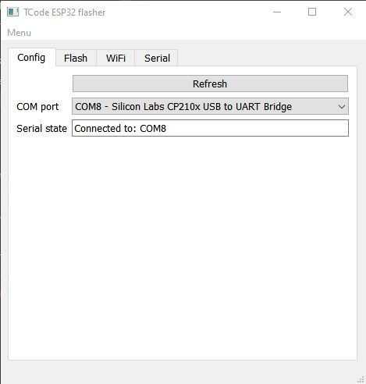

If your ESP32 isn't recognized as a COM port you may need to install the drivers for your USB chip.
For micro USB Devkit https://www.silabs.com/developers/usb-to-uart-bridge-vcp-drivers
For USB-C Devkit (CH340) https://learn.sparkfun.com/tutorials/how-to-install-ch340-drivers/all

Select the Flash tab (most should leave everything at default on this tab) If using the S3 Zero of another supported board, Select it in the module drop down (Not pictured) and click “FLASH NOW”
Note: If you get a error that mentions the boot mode, hold the boot button in the Devkit until the dots stop.
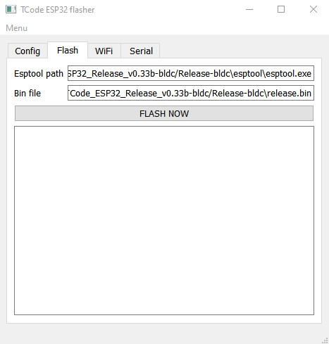

After flashing you should see this if successful
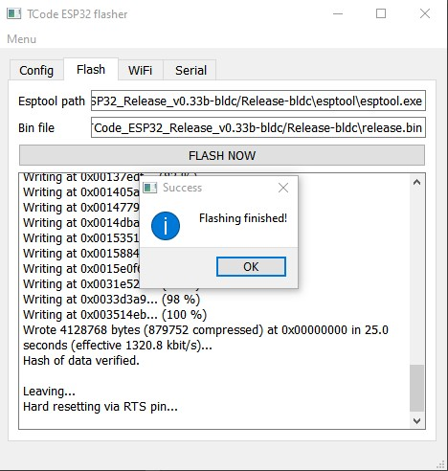

Now that your image is flashed time to configure the wifi if you wish to do so
IMPORTANT! The ESP32 S series (Devkit v1) is ONLY compatible with 2.4ghz WiFi

You can either configure Wifi with the flasher, AP mode or Serial monitor.
Skip to the chosen section below.

Flasher configuration:
Select the WiFi tab and enter your 2.4ghz SSID and password
Click Save
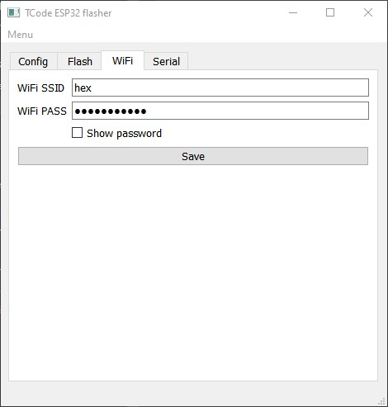

On success, the app will switch to the Serial tab to view the output.
Here you can validate the ESP32 connects to your network.
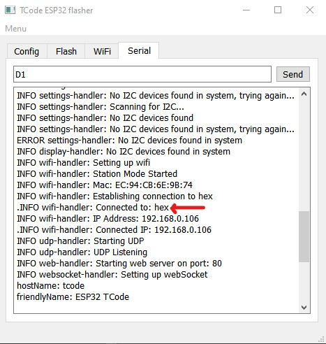
You can also enter other Tcode commands here to test your device is working correct.
IMPORTANT! On BLDC devices, You must set the DeviceType and EncoderType via serial or web page before the device will work.

AP configuration:
Check your available wifi networks
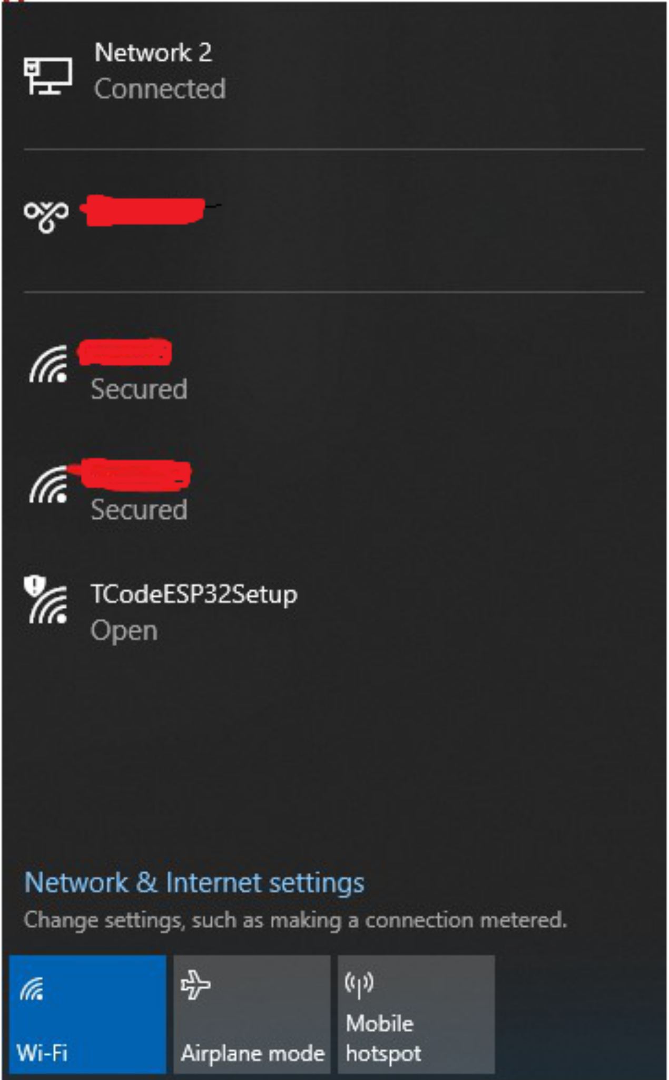
Connect to TcodeESP32Setup (leave connect automatically unchecked)
Password is: tcode_6969
Once connected (It can be slow be patient. About 30 secs or so)
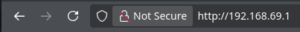
Open your internet browser and navigate to 192.168.69.1
Enter your wifi ssid and password and change the network info if required.
Note: If you’re NOT connecting to an AP/Router SSID, you may want to set a different AP Mode SSID/Password for privacy/security. Connecting the device to a router will disable AP Mode unless the network cant be reached for some reason.
You can also change other settings such as board type and device type.
Board type will change the pinout for the board
Device type will change the setup page and the way the code handles the signals.
You can change other settings or you can wait until reboot happens.

BLDC based devices have an encoder type field
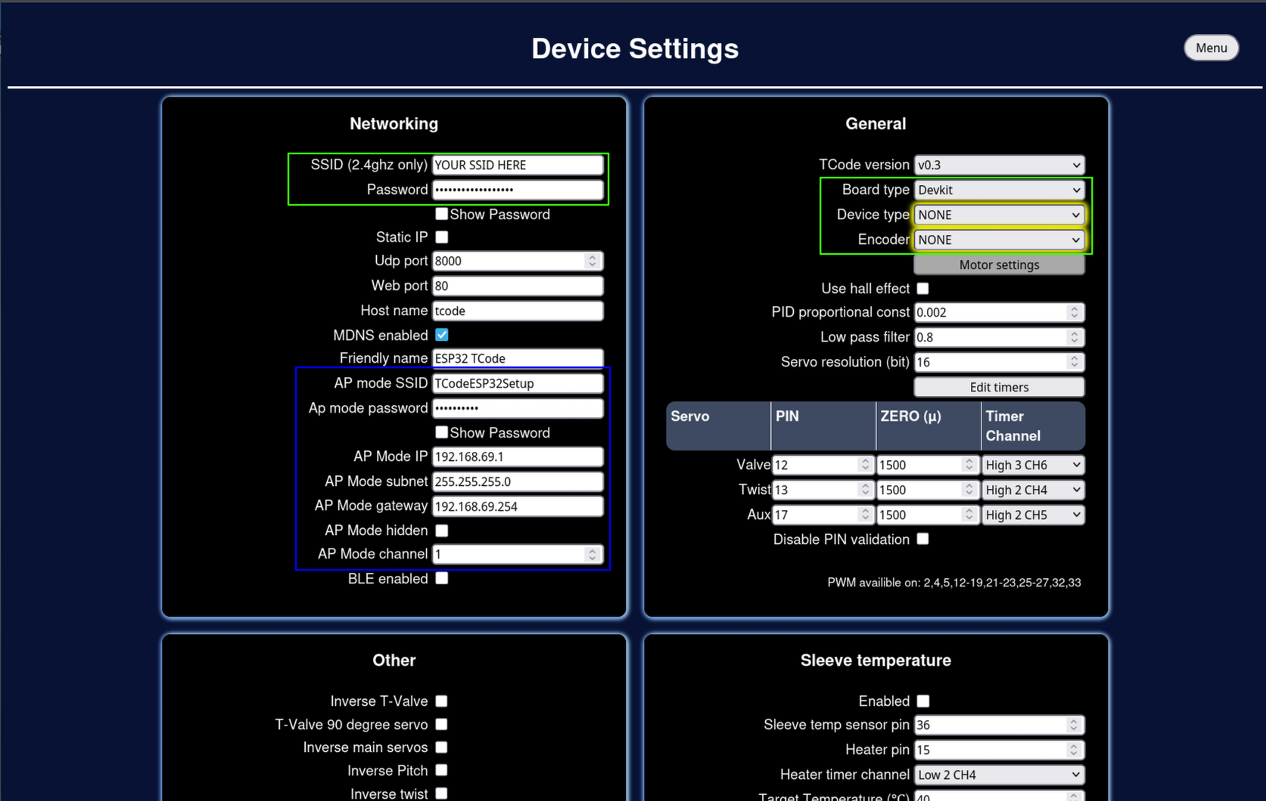

The settings will auto save. Wait for the Settings saved text to appear and the Menu/Restart device buttons will flash..

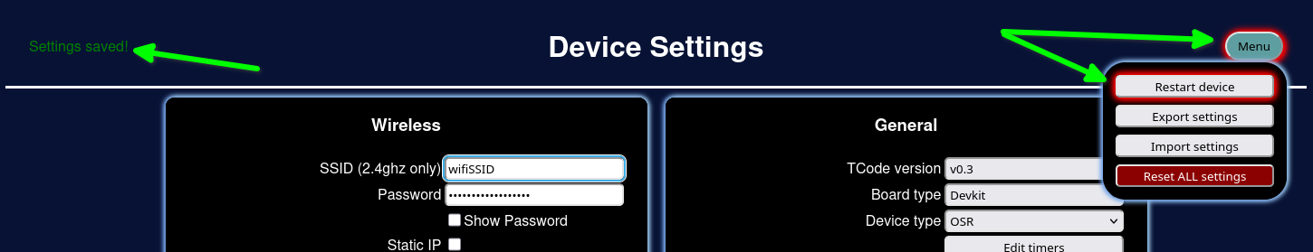
Click restart device OR unplug and re-plug the usb powering the ESP32.

Your device should reboot and connect to the network if you entered a valid SSID/Password.

You can verify this by using serial monitor:
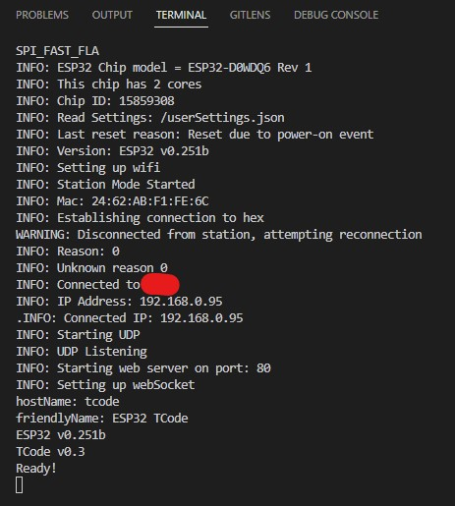

or checking your router dhcp for the ESP32.

You should now be able to access the configuration page from or what ever you type into the Host name field on the configuration.
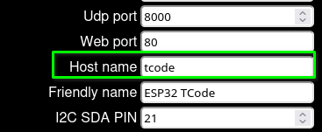
Once you have this IP address you can get into your machine settings via the web browser.

From here you can view the default pin out and change them if you know what you are doing. -1 means disabled. You cant disable the main servos for the selected Device type
You may want to set up things like servo frequency in the timer setup
Or calibrate your servo zero positions.
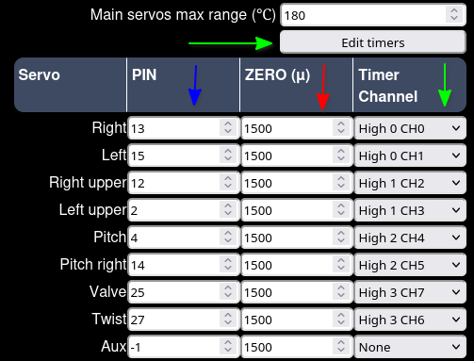
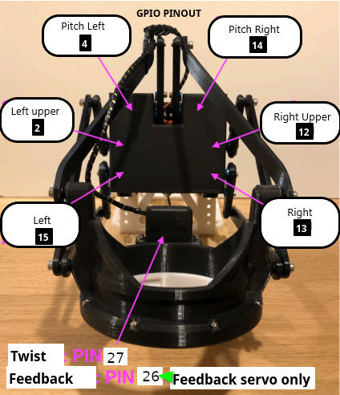
Here is the default SR6 pinout for reference:

Serial monitor configuration

If you can't connect to the APMode method above for some reason you can configure most device settings over serial communications including the wifi router login settings.

Connect to the esp32 via Serial monitor in Arduino ide or your app of choice
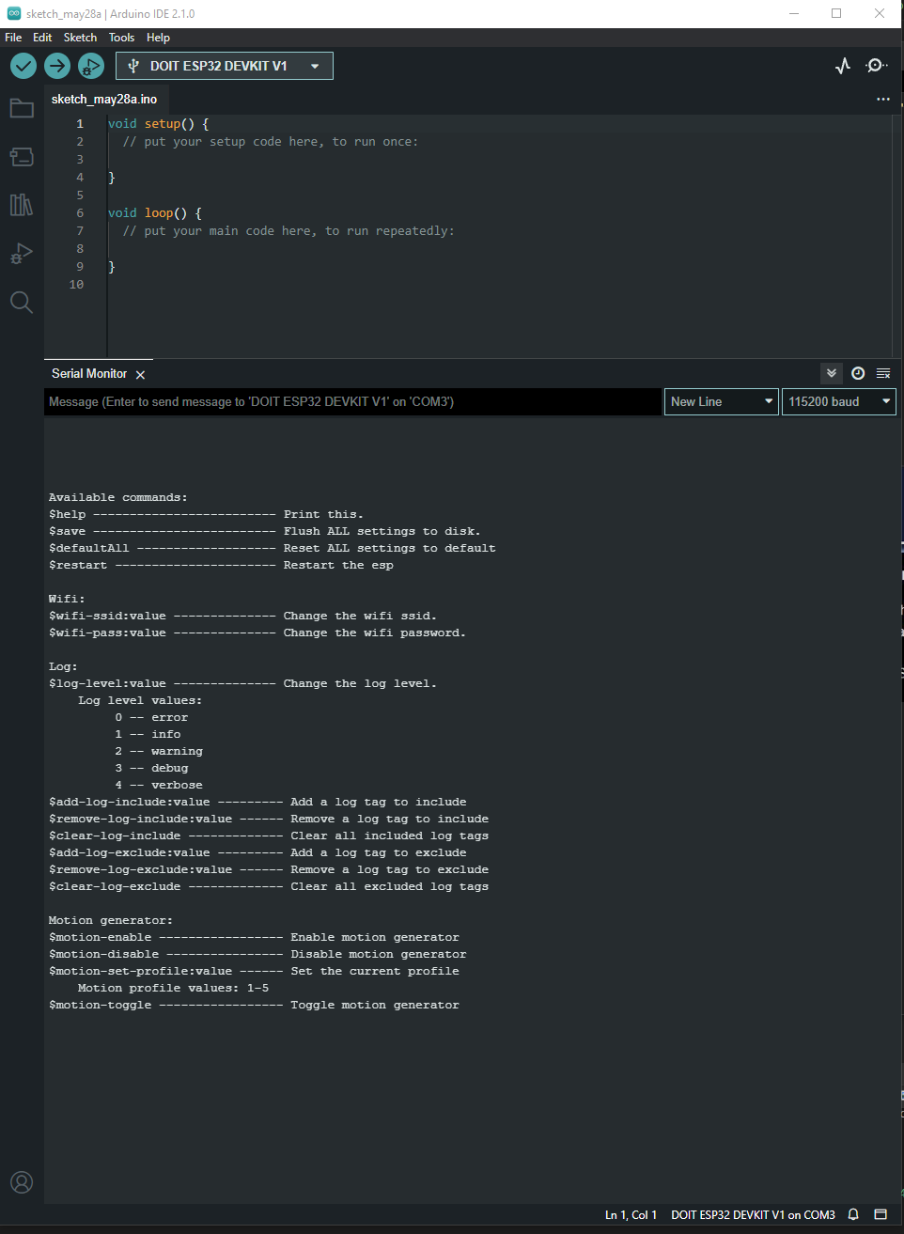
Enter the command #help to see a list of available commands.
IMPORTANT! On BLDC devices, You must set the DeviceType and EncoderType via serial or web page before the device will work.

Conclusion

Now wifi is connected you can get to the web page via either http://tcode.local or http://<ipaddress> and configure the rest this firmware.
Enjoy!

